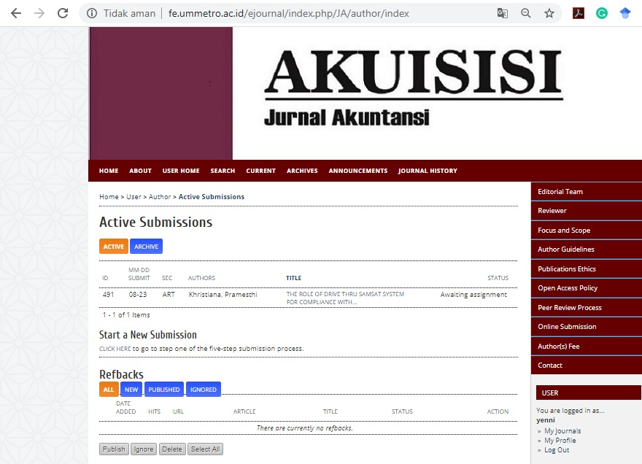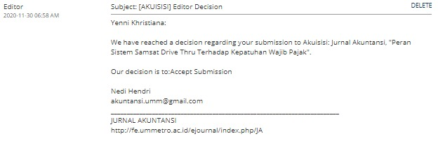C:\Users\FRESH\Downloads\WhatsApp Image 2021-04-03 at 12.08.37 (1).jpeg